UCAS https://www.ucas.com/undergraduate/student-life/mental-health-and-wellbeing/mental-health-and-wellbeing-starting-new-job-or-apprenticeship
Information and signposting for those starting work or an apprenticeship.
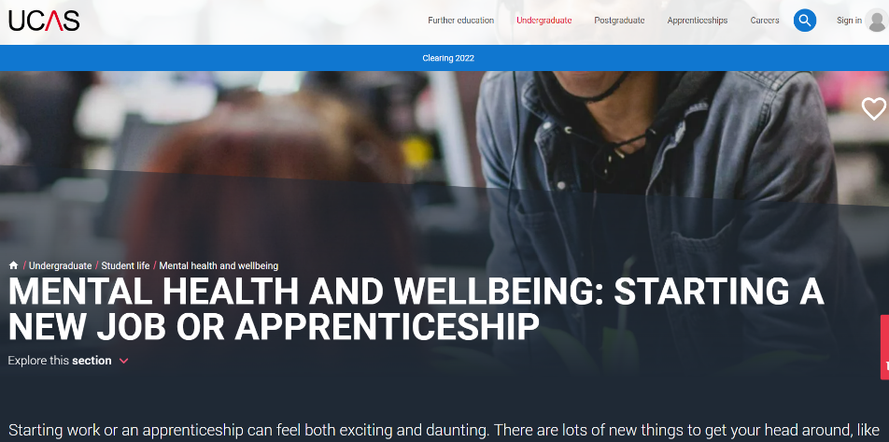

Mind https://www.mind.org.uk/workplace/
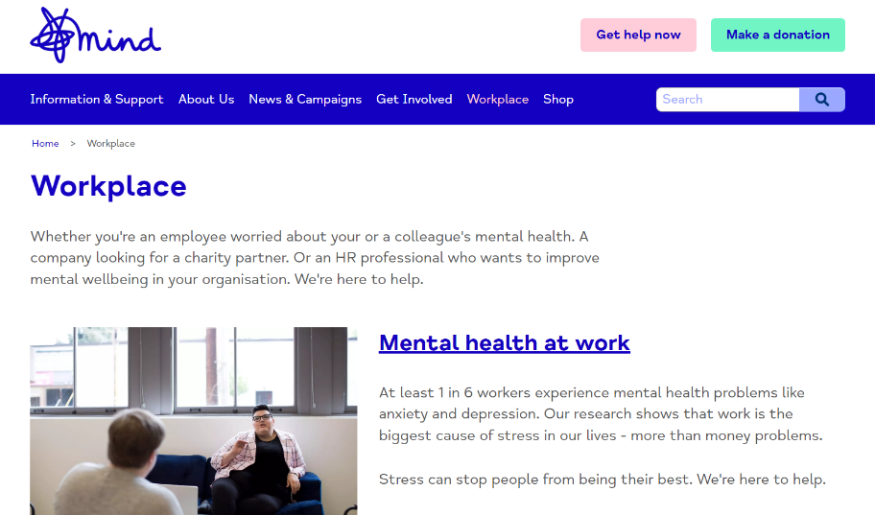
Remploy https://www.remploy.co.uk/employers/mental-health-and-wellbeing/access-work-mental-health-support-service-apprentices/
Support available for any apprentice experiencing mental health difficulties at work.
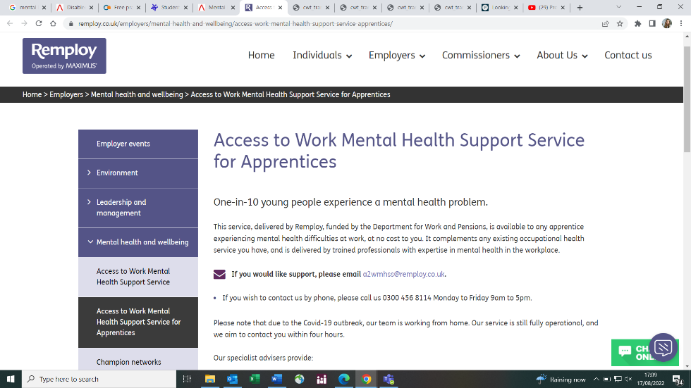

Institute for Apprenticeships https://www.instituteforapprenticeships.org/raising-the-standard-best-practice-guidance/welfare-and-wellbeing-raising-the-standards/
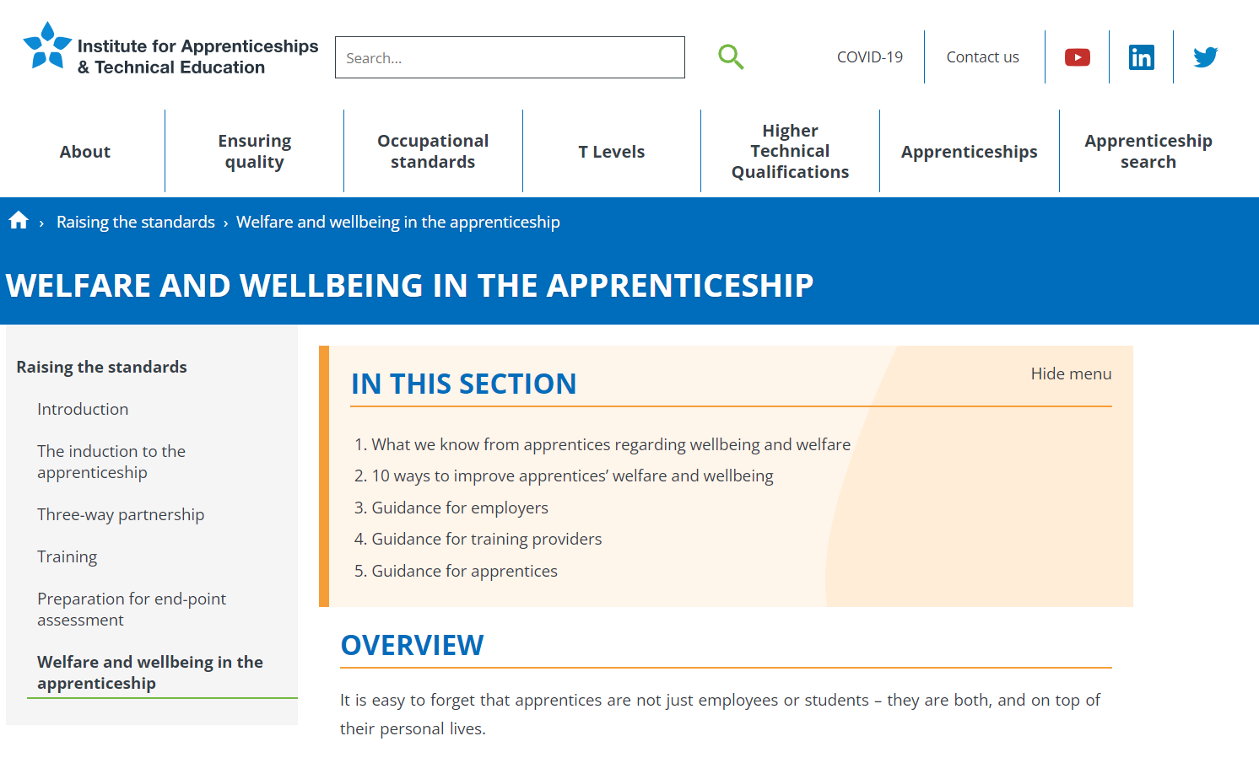
Able Futures https://able-futures.co.uk/

