Prospects https://www.prospects.ac.uk/applying-for-university/university-life/looking-after-your-mental-health-at-university

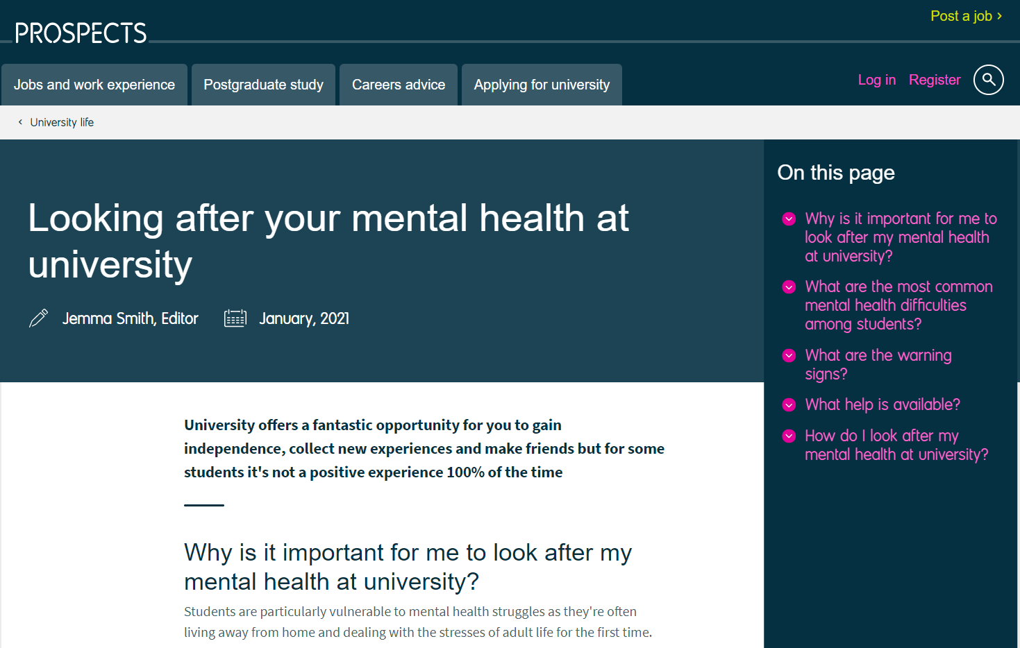
Outside of university try:
- Your GP - if you're worried about your mental health it's essential that you visit your GP. They can give you a medical diagnosis and can refer you to appropriate services.
- The Samaritans - if you feel you need immediate help, call 116 123, any time of day.
- Family and friends - talking about your struggles can be a huge relief. Don't feel like a burden, your family and friends want to help.
- Charities - organisations such as the Mental Health Foundation, Mind, Papyrus, Sane and Student Minds provide excellent advice and support.
https://www.youtube.com/watch?v=7bfpvLev5N4

Student Minds https://www.studentminds.org.uk/transitionintouniversity.html
Student mental health charity – free resources, tips and student stories. Support resource specifically for transition to university. Online peer support groups and Student Space which offers text support and further information and resources.
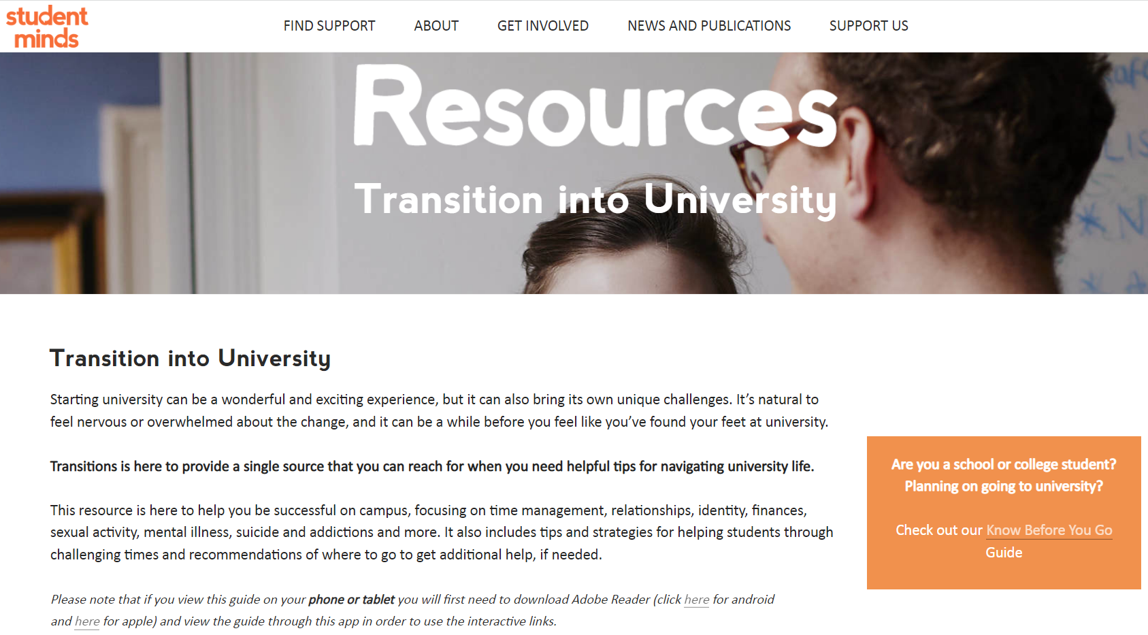

https://studentspace.org.uk/
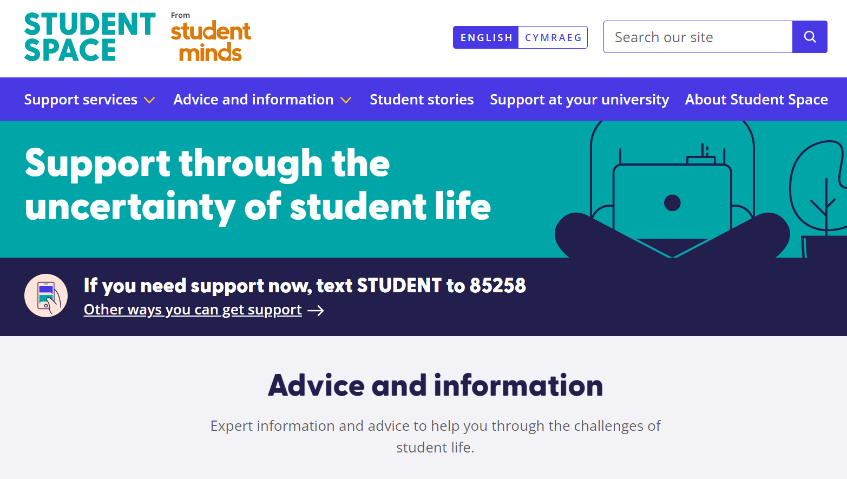

Charlie Waller https://charliewaller.org/mental-health-resources/change/results-and-clearing/
Information and resources on Charlie Waller about the transition to university.
They also have specific resources to support the transition for:
- LGBTQ+ students
- Care leavers
- Young carers
- Those who’ve had challenging experiences in childhood
- Those who may be concerned about fitting in, possibly due to their religion, cultural background, ethnicity, or nationality among other things.
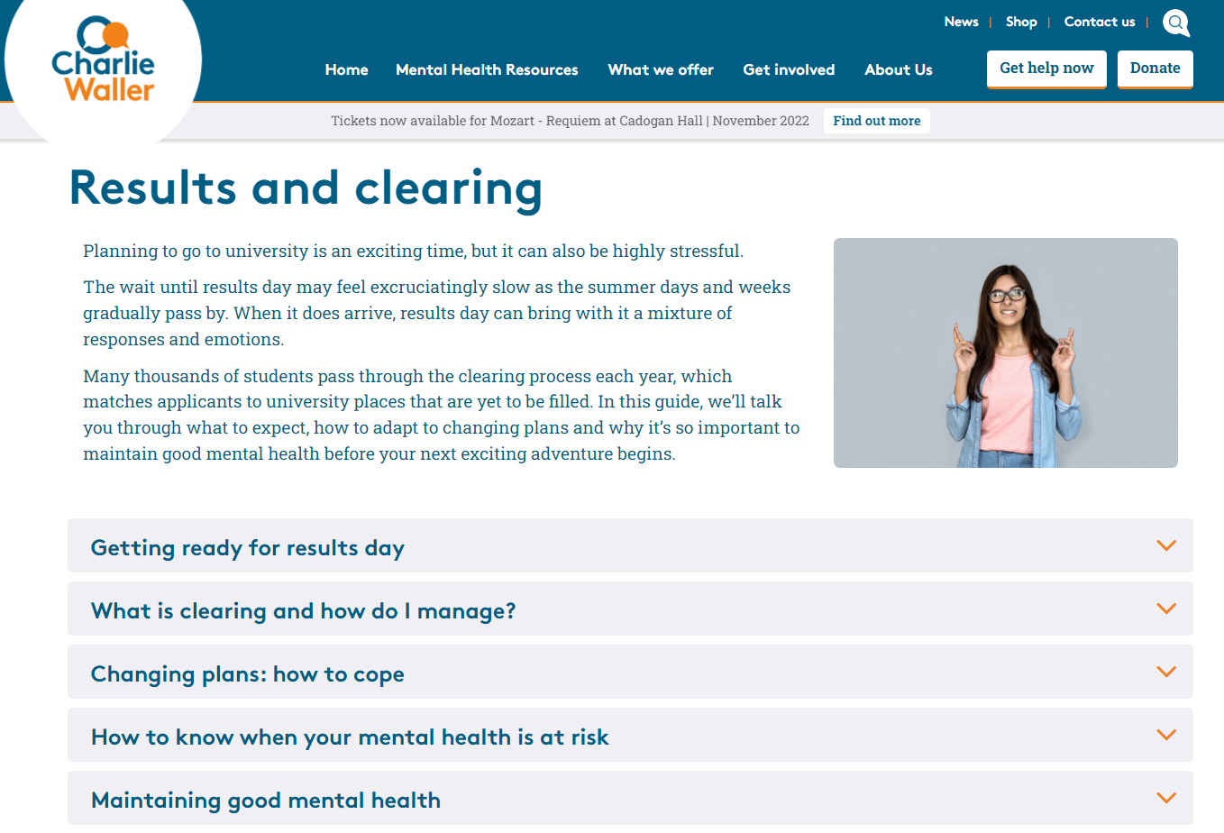

Mind https://www.mind.org.uk/information-support/tips-for-everyday-living/student-life/
Resource to inform and support all students at all places of study.
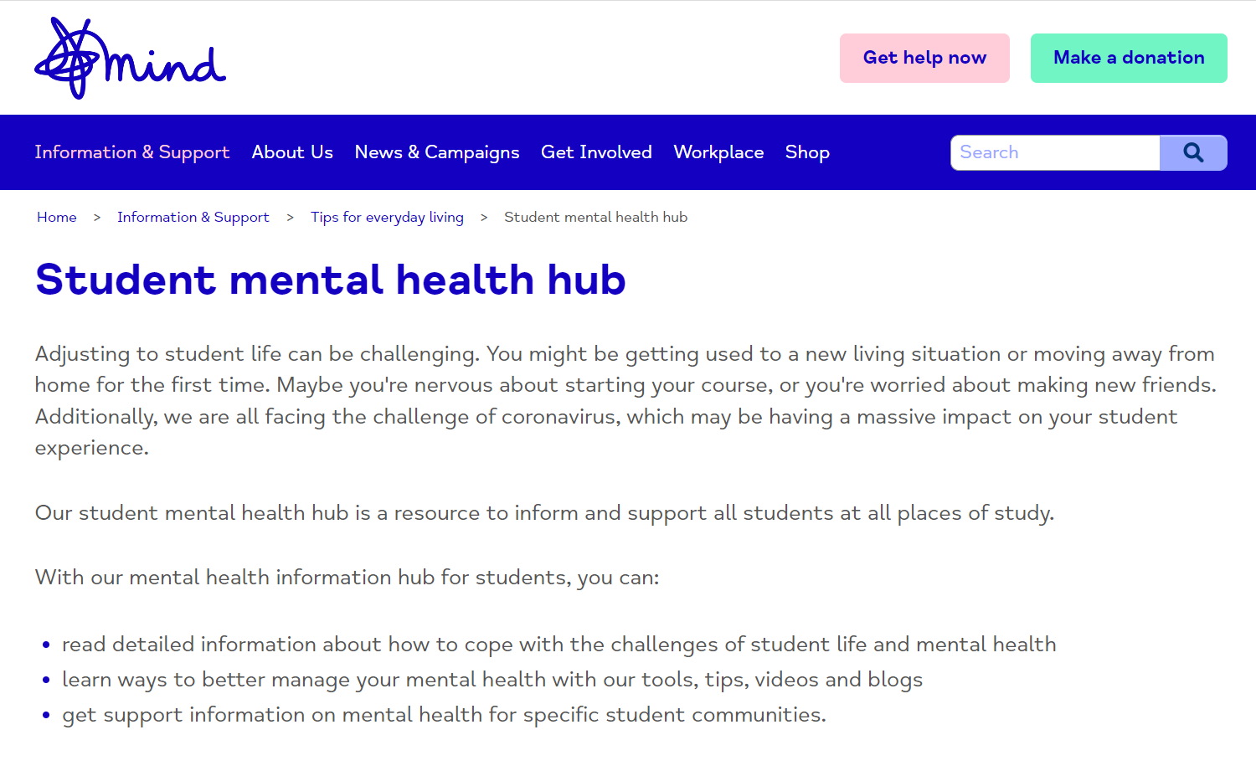
Specific information and support for some student groups:
